HD 95128 (47 Ursae Majoris)

HD 95128 is a 1.063 M☉, G0 V star1. Based on 409 RV Lick data obtained between 1987 and 2010, 91 RV HIRES data obtained between 2009 and 2020 and 337 RV Apf data obtained between 2013 and 2019, the CL survey reported a GP (HD 95128b) signal with a period of days, a minimum mass of MJup and an eccentricity of , a second GP (HD 95128c) signal with a period of days, a minimum mass of MJup and an eccentricity of and a LPGP (HD 95128d) with a period of days, a minimum mass of and an eccentricity of .

In the present study, in addition to the CL survey’s dataset, 43 RV CDES data obtained between 1998 and 2008, 35 RV CES data obtained between 1998 and 2006, 54 RV ELODIE data obtained between 1996 and 2006 and 77 RV HET data obtained between 2004 and 2007 were used. DPASS and MCMC (1000 walkers and 1000000 iterations) were used to fit the data. The properties found for planets HD 95128 b and c reported in the CL survey were within the error bars associated with the values found in the present analysis. For HD 95128d, a period of 12963 days, a minimum mass of 1.4 MJup and an eccentricity of 0.32 were found with DPASS, with a corresponding rms of residuals of 7.3 m/s. Using MCMC, the sampling found was very strongly peaked around 2 MJup for the minimum mass. However, solutions with a minimum mass up to 150 MJup were also found without changing significantly the log-likelihood. Also,a period between 150000 and 410000 days and an eccentricity between 0.39 and 0.89 were found using MCMC. Due to the large dispersion in the RV data, specifically in the Lick data, the stellar RV cannot be constrained which does not allow to properly determine the orbital parameter and the minimum mass of HD 95218d.

To explore the range of possible values, the semi-major axis was fixed to different values and the data fitted with DPASS. *a* up to 590 au gave the same rms of the residuals as with *a* left free. In this case (referred to as constrained *a*), the minimum mass is 2.3 MJup and the extremely high eccentricity is 0.98.

To test the impact of the stellar RV offset, it was also fixed to different values and the data, once corrected from the instrumental offsets for clarity purposes, were fitted with DPASS. It appears that stellar RV offset up to 60 m/s does not significantly change the rms of the residuals (8.2 m/s against 7.3 m/s with stellar RV offset left free). In this case (referred to as constrained offset), the semi-major axis is 180 au, the minimum mass is 173 MJup and the eccentricity is 0.13.

The fits are shown in Fig 1, and the corner plot in Fig 2, and the results summarized in Table 1.

Conclusion: The properties found in the CL survey for HD 95128d are not confirmed. Additional data are needed to further constrain its orbital properties.

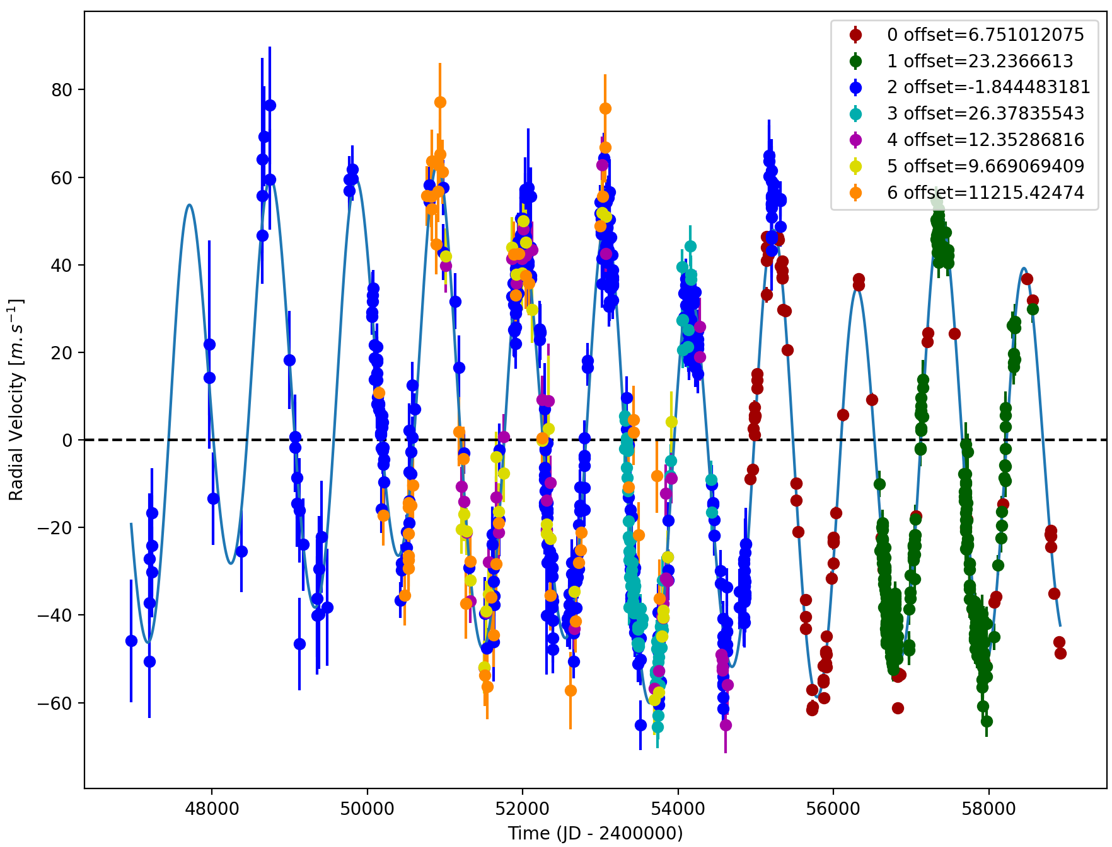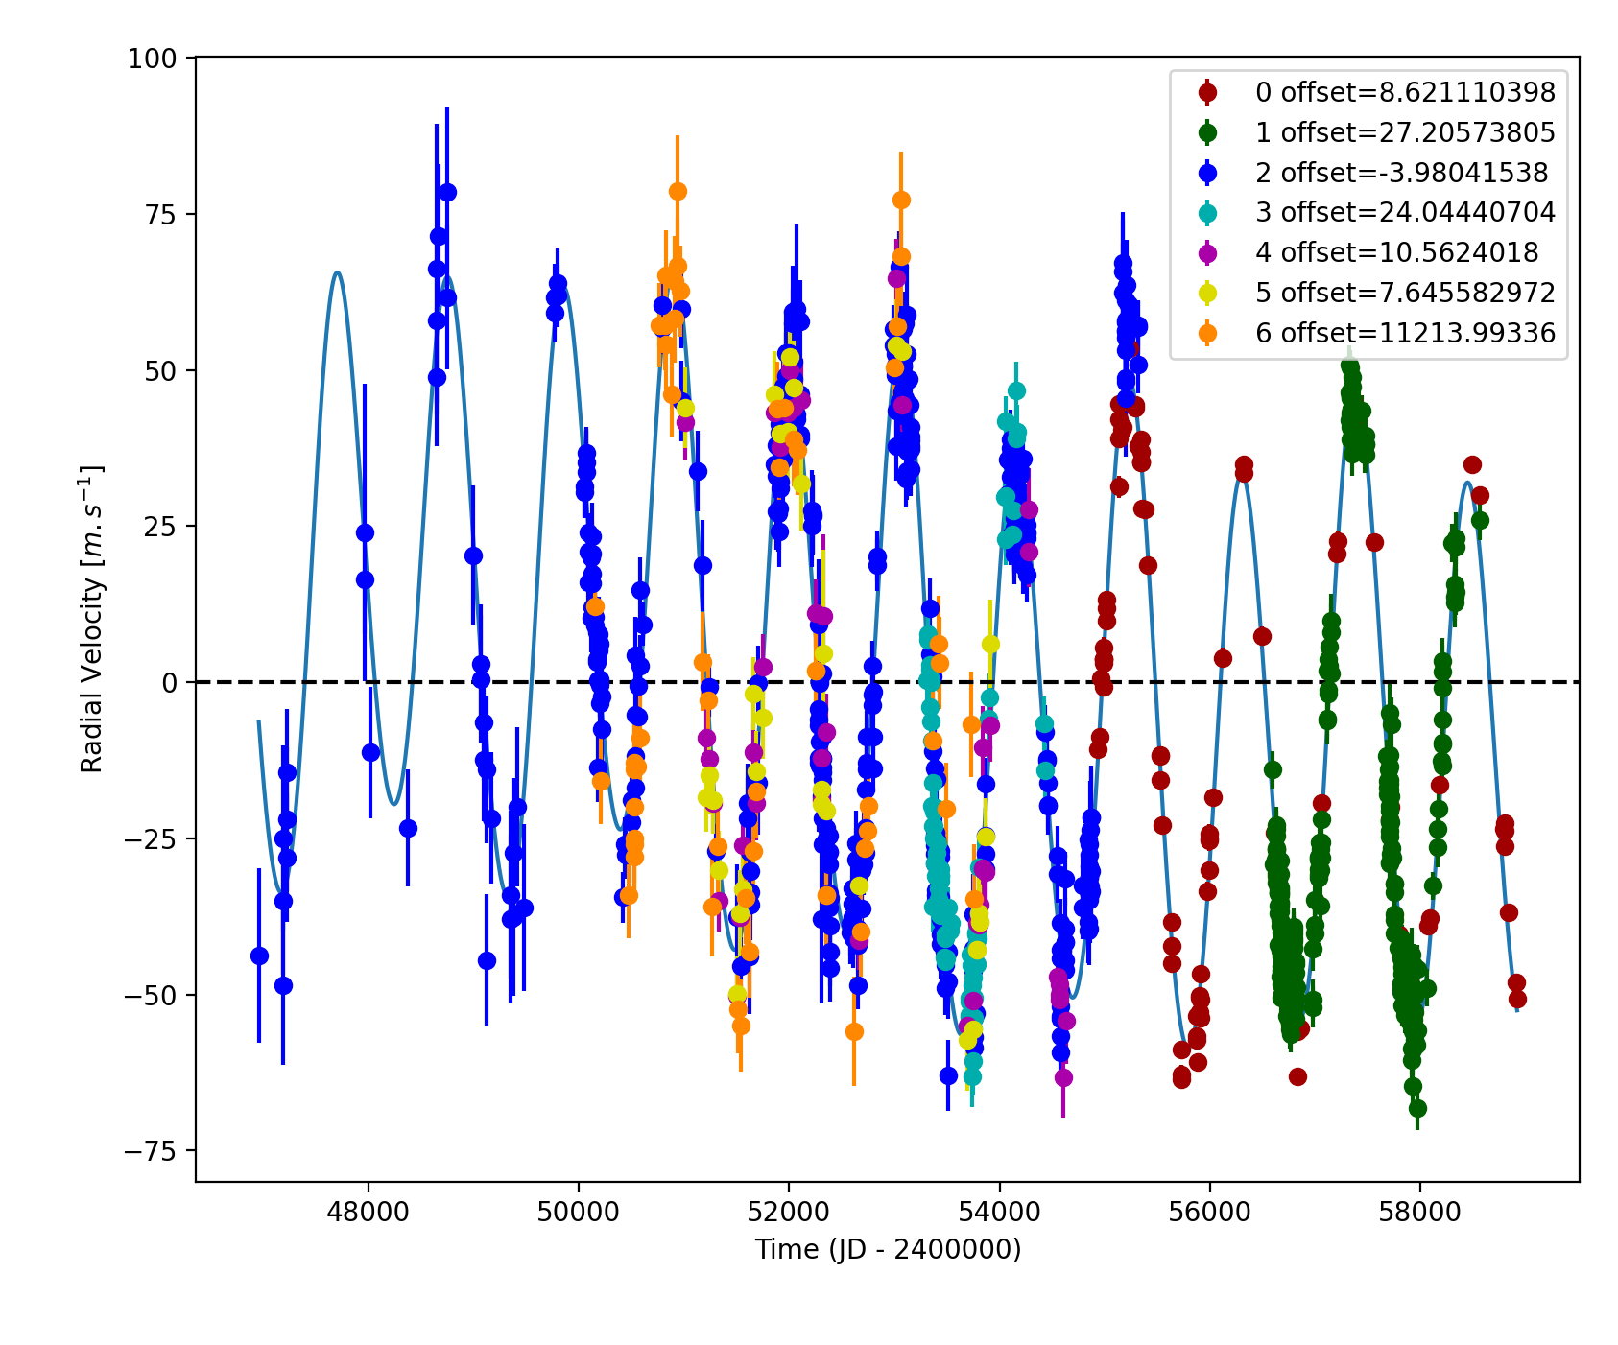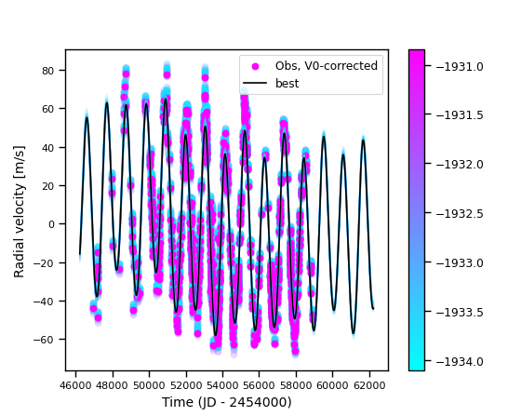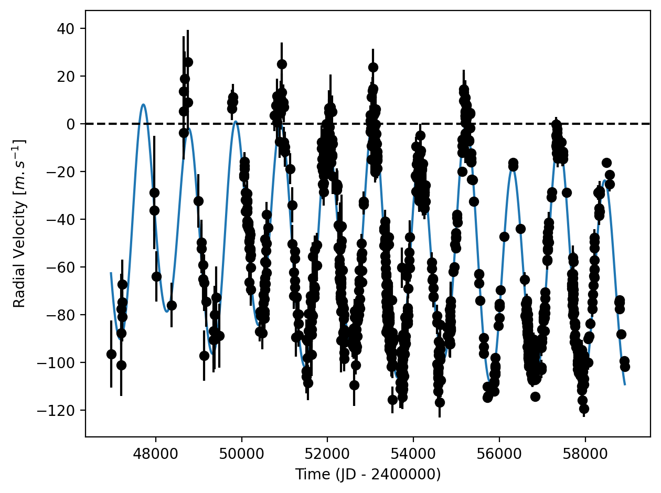

Figure 1: Top left: fit of the HD 95128 RV with DPASS. Red - Hir04, green - Apf, blue - LICK, cyan - CDES, purple - CES, yellow - HRS, orange - ELODIE. The blue curve shows the best fit. Top right: fit of the HD 95128 RV with DPASS, with the minimum *a* fixed at 590 au. The points are the same as on the left. The blue curve shows the best fit. Bottom left: fit of the HD 95128 RV with DPASS, with a subtracted stellar offset fixed to 60 m/s. Black points correspond to the data corrected for the instrumental offsets. The blue curve shows the best fit. Bottom Right: fit of the HD 95128 RV using MCMC. The black curve shows the best fit. The colorbar corresponds to the log-likelihood of the fits.

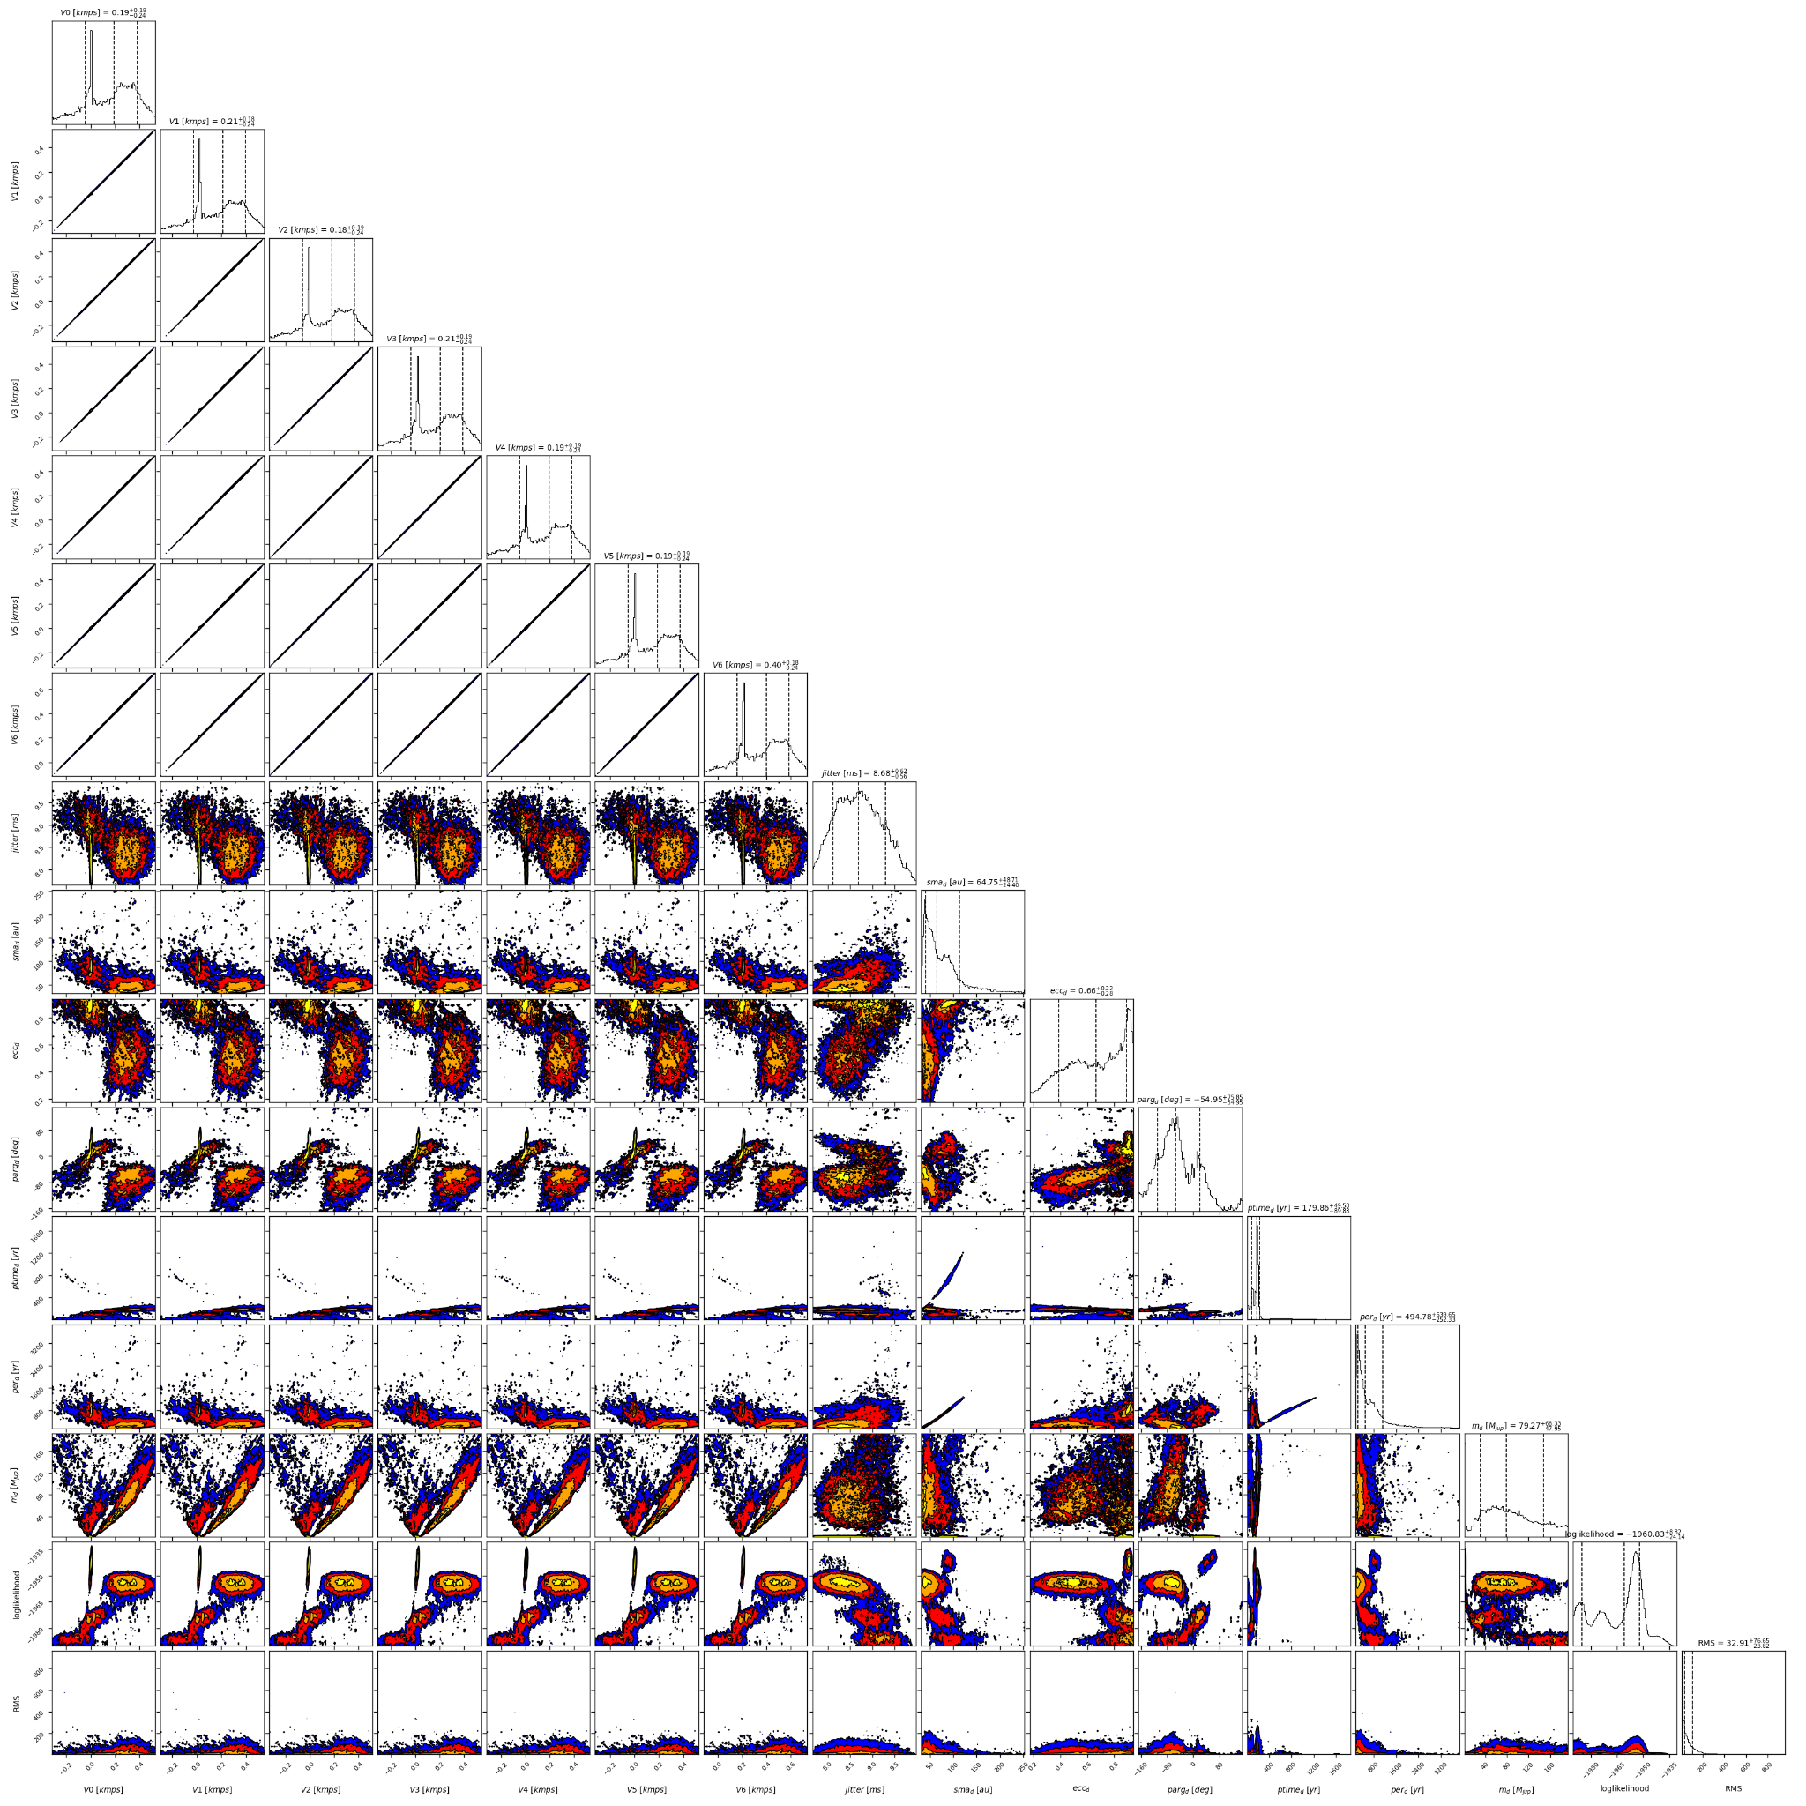

Figure 2: Corner plot of posteriors for the properties of HD 95128d.

| Parameter | Priors | | | | Posteriors | | | | CL survey |
| --- | --- | --- | --- | --- | --- | --- | --- | --- | --- |
|  | DPASS | | | MCMC | DPASS | | | MCMC |  |
|  | Free priors | Constrained *a* | Constrained offset | Free priors | Free priors | Constrained *a* | Constrained offset | Free priors |  |
| *a* (au) | b: [0,100]  c: [0,100]  d: [0,100] | b: [0,5]  c: [0,5]  d: up to 600 | b: [0,5]  c: [0,5]  d: [0,1000] | b: [1.5,2.5]  c: [3,4]  d: [5,100] | b = 2.1  c = 3.4  d = 10.9 | b = 2.1  c = 3.4  d = 590 | b = 2.1  c = 3.5  d = 180 | b = 2.08 ± 0.01  c = 3.48 ± 0.03  d = 40 – 113 | b =  c =  d = |
| Msin(i) (MJup) | b: [0,200]  c: [0,200]  d: [0,200] | b: [0,200]  c: [0,200]  d: [0,1000] | b: [0,20]  c: [0,20]  d: [0,1000] | b: [1,3]  c: [0.1,1]  d: [0.5,20] | b = 2.4  c = 0.5  d = 1.4 | b = 2.4  c = 0.5  d = 2.3 | b = 2.4  c = 0.5  d = 173 | b = 2.44 ± 0.04  c =  d = 2 – 148 | b =  c =  d = |
| Eccentricity | b: [0,0.95]  c: [0,0.95]  d: [0,0.95] | b: [0,0.95]  c: [0,0.95]  d: [0,0.98] | b: [0,0.95]  c: [0,0.95]  d: [0,0.95] | b: [0,0.2]  c: [0,0.5]  d: [0,0.95] | b = 0.05  c = 0.3  d = 0.32 | b = 0.05  c = 0.28  d = 0.98 | b = 0.05  c = 0.28  d = 0.13 | b = 0.04 ± 0.01  c =  d = 0.39 – 0.91 | b =  c =  d = |
| Instrumentals offsets (km/s) | [-100,100] | [-100,100] | up to 0.060 | Hir04: [-1,1]  Apf: [-1,1]  LICK: [-1,1]  CDES: [-1,1]  CES: [-1,1]  HRS: [-1,1]  ELODIE: [10,12] | Hir04: 0.007  Apf: 0.023  LICK: -0.002  CDES: 0.027  CES: 0.013  HRS: 0.010  ELODIE: 11.216 | Hir04: 0.009  Apf: 0.027  LICK: -0.004  CDES: 0.024  CES: 0.011  HRS: 0.008  ELODIE: 11.214 | 0.060 | Hir04: -0.047 – 0.378  Apf: -0.025 – 0.397  LICK: -0.063 – 0.364  CDES: -0.037 – 0.391  CES: -0.048 – 0.379  HRS: -0.051 – 0.377  ELODIE: 11.157 – 11.584 |  |
| Stellar jitter (m/s) | [0,40] | [0,40] | [0,40] | [0,20] | 7.7 | 7.8 | 9.5 | 7.9± 0.4 |  |
| Argument of periastron (°) | b: [0,360]  c: [0,360]  d: [0,360] | b: [0,360]  c: [0,360]  d: [0,360] | b: [0,360]  c: [0,360]  d: [0,360] | b: [0,360]  c: [0,360]  d: [0,360] | b = 323  c = 65  d = 51 | b = 325  c = 65  d = 73 | b = 337  c = 66  d = 273 | b =  c =  d = |  |
| Phase | b: [0,1]  c: [0,1]  d: [0,1] | b: [0,1]  c: [0,1]  d: [0,1] | b: [0,1]  c: [0,1]  d: [0,1] | b: [0,1]  c: [0,1]  d: [0,1] | b = 0.30  c = 0.47  d = 0.92 | b = 0.30  c = 0.22  d = 0.01 | b = 0.36  c = 0.76  d = 0.54 | b =  c = 0.23 – 0.92  d = 0.10 – 0.89 |  |

Table 1: HD 95128. Summary of priors and posteriors obtained with DPASS and MCMC, compared to the properties reported by the CL Survey.

References

1. Takeda, G. et al. Structure and Evolution of Nearby Stars with Planets. II. Physical Properties of ~1000 Cool Stars from the SPOCS Catalog. *Astrophys. J.* *Suppl. Ser.* 168, 2 (2007).